DISTRICT 8 4-H PHOTOGRAPHY CONTEST


Rules & Guidelines

PURPOSE
The Texas 4-H Photography Contest encourages self-expression and allows youth to demonstrate skills learned in the area of photography, including the use of photographic equipment and process of photographs.

OBJECTIVES
- To develop life skills in composition, light, story line, posing, and awareness.
- To encourage 4-H members to use photography as a meaningful communication tool in their lives.
- To provide photography project showcase opportunity for 4-H members.
- To continue to share the message of 4-H.
- To utilize photographs which can promote and strengthen the 4-H program.

RESOURCES
Adventures with Your Camera – A (Grades 3 to 5) Available from National 4-H Council Supply
Adventures with Your Camera – B (Grades 6 to 9) Available from National 4-H Council Supply
4-H Guide to Digital Photography by Daniel Johnson. (Available from Amazon.com)
Texas 4-H and Youth Development Photography Project Resource Page:
http://texas4-h.tamu.edu/project_photography
Any reference to a product or company is not to endorse or support them and their causes. Links to companies are provided for their educational resources only.

IMPORTANT DATES
County Entry Deadline: | Thursday, September 12, 2013 (No entry fee at county level)
District Entry Deadline: | Photos entered at District must qualify at the county level first!
District Entry Fee: | $5 per photo
Display of District Photos: | October 3-12, 2013  Heart O’ Texas Fair, Waco, Texas  Creative Arts/Exhibit Building

CONTEST RULES AND GUIDELINES
PLEASE READ ALL RULES AND GUIDELINES. PHOTOS NOT ADHERING TO GUIDELINES WILL NOT BE JUDGED!!

- Eligibility. Participants must be 4-H members currently enrolled and have an “active” status on 4-H Connect with the Texas 4-H and Youth Development Program and actively participating in the Photography project.

- Age Divisions. Age divisions are determined by a participant’s age as of August 31, 2013 as follows:
- Eligibility of Photos. All photographs must have been taken by the 4-H members between the dates of October 1, 2012 and time of entry. Photos may be submitted only one time and in only one category.
Division | Ages | Birth date between:
Junior | 8 years old and in 3rd grade or 9 - 10 years | Sept 1, 2002 – Aug 31, 2005
Intermediate | 11-13 years of age | Sept 1, 1999 – Aug 31, 2002
Senior | 14 - 18 years of age | Sept 1, 1994 – Aug 31, 1999

Please note: This is NOT the qualifying contest for the state senior contest that will be held in spring 2014. This contest is in addition to the state senior contest and senior members wishing to enter the state contest should contact their County Extension Agent for details.

- Number of Entries per County. A county may have only one entry per category in each age division for a total of 45 entries per county. Photos entered at District must qualify at the county level first!

- Entry Deadline & Fee. All entries for the District contest must be electronically submitted through 4-H Connect by the deadline. Deadlines vary by county, so you will need to contact your County Extension Agent. Each photo will have a $5 entry fee. Photos entered at District must qualify at the county level first!


- Manipulation of Photos. Photos can only have minor manipulation, touch-up performed for all categories except Digital Darkroom. The only acceptable manipulation includes correction of red-eye, cropping, and straightening of photos. Any other manipulation, edits, to a photo would require the photo to be entered into the Digital Darkroom category.

- Format of Photograph. Photographs should be taken at the highest resolution possible. Photographs must be in a .jpeg, .jpg, or .gif format. Files submitted may not be larger than 2,048k (2MB). There is no minimum size requirement, however, your photograph must be large enough that it can be clearly evaluated for the contest (i.e. if it is too small, it can be disqualified).

- Copyright and Content. Photos that are deemed obscene, vulgar, sexually oriented, hateful, threatening, or otherwise violate any laws are strictly prohibited. The Texas 4-H and Youth Development Program in District 8 respects the rights related to copyright laws and intellectual property. All photos should be based on a 4-H member’s original photograph taken by the 4-H member. Use of a photo from other sources/people without permission is not allowed and will lead to disqualification of the photo and possibility all entries by the 4-H member. The Texas 4-H and Youth Development in District 8 reserves the right to refuse inappropriate or unsuitable entries.

- Model and Property Releases. Any 4-H member submitting a photograph acknowledges that they have sufficient permission of any recognizable locations or people appearing in their photograph(s). This permission is hereby granted to both the photographer and the Texas 4-H and Youth Development Program in District 8 to publish and use as needed. Written documentation should be retained by the 4-H member and will be requested by the Texas 4-H and Youth Development Program in District 8 if needed.

- Disqualification of an Entry. An entry that does not follow the rules or category guidelines will automatically be disqualified. A general notice specifying reason(s) for disqualification will be returned to the county. Reasons for disqualification:
  - Extremely poor quality (resolution/size)
  - Photograph file not labeled correctly to ensure identification.
  - Does not meet category criteria (see category descriptions)
  - Inappropriate or unsuitable photograph
  - Manipulation of photo beyond what is allowed.
  - Photograph entered into multiple categories
  - More than one entry in a category from a county.
  - Photo was NOT entered into the 4-H CONNECT system.
  - County did not select/certify photo to represent county.
  - Entry fee not paid or only partial fee paid.

- Text on Photographs. Beyond the Storyboard and Digital Darkroom categories, photographs should not contain “user placed text.” This includes such things as comments or titles. Text or wording that is part of the photograph (i.e. photo of a street sign, etc.) is acceptable.

- Release of Liability. The Texas 4-H and Youth Development Program, Texas A&M AgriLife Extension, the Texas 4-H Youth Development Foundation and/or its employees/agents involved in the contest will not be held liable for missing, mislabeled, or non-displayed photographs. By entry the 4-H member accepts this release.

- Display and Future Rights Use Rights. By submitting an entry to the contest, the 4-H member grants permission to the Texas 4-H and Youth Development Program, Texas A&M AgriLife Extension, the Texas 4-H Youth Development Foundation, and any other public or private agency authorized by the Texas 4-H and Youth Development Program, the use, and rights associated to the use of the photographic likeness, in promotional publications, and other media, without compensation. Certain photos maybe used for 4-H program and marketing uses. By entry the 4-H member accepts these conditions of display and future use.

- Judges. Judges will determine the placings. Their decision on all entries is final.

- Retention of Photos. All photographs will be retained by the Texas 4-H and Youth Development Program in District 8 for which they may be used in marketing and program promotion.

- Awards. Blue, Red, and White awards will be given to entries based on the score sheet criteria. This system is known as the Danish system, and photos will not be judged against each other, but against the set criteria/standards instead.

Best of Show awards will be given to one photo in each age division.

A Spirit of 4-H Award will be giving for the photograph that best demonstrates the spirit of 4-H. This award can be awarded to any age division and category. Only one award will be given for the entire contest.

- Announcement of Results. Results will be emailed after the judging to County Extension Agents and county offices.

PROCESS OF SUBMITTING PHOTOGRAPHS FOR DISTRICT JUDGING
All entries for the 2013 District 8 Photography Contest will be completed using 4-H Connect. Please read these submission rules very careful to prevent disqualification of entries!

Photos entered at District must qualify at the county level first!

PLEASE READ THESE RULES VERY CAREFULLY AND FOLLOW EVERY STEP CORRECTLY!!!

- Formatting the Photograph. Photographs should be taken at the highest resolution possible. Photographs must be in a .jpeg, .jpg, or .gif format. Files submitted may not be larger than 2,048k (2MB). There is no minimum size requirement, however, your photograph must be large enough that it can be clearly evaluated for the contest (i.e. if it is too small, it can be disqualified).

- Labeling/Naming the Photograph. Each photograph will need to be clearly labeled with the Age Division, Category, County, 4-H member’s first and last name and the name of the category (see below for label name).
For example: Junior 4-H member John Smith from Bell County entering the Animals-Wildlife category would upload a file labeled: Junior_Wildlife_Bell_John_Smith.jpg

Please use the following labels for the categories:
CATEGORY | FILE LABEL NAME |  | CATEGORY | FILE LABEL NAME
ANIMALS - DOMESTIC | Domestic |  | MARINE/AQUATIC | Marine
ANIMALS - WILDLIFE | Wildlife |  | NATURE & LANDSCAPE | Nature
CATCH ALL | All |  | NIGHT PHOTOGRAPHY | Night
DETAILS & MACROS | Details |  | PEOPLE | People
DIGITAL DARKROOM | Darkroom |  | PLANT/FLORA | Plant
DOMINANT COLOR | Dominant |  | STORYBOARD | Storyboard
ELEMENTS OF DESIGN | Elements |  | THEME | Theme
FOOD | Food

- Submitting the Entry. Photo submission for the District contest will be on 4-H Connect between. Deadlines vary by county, so you will need to contact your County Extension Agent. Photos entered at District must qualify at the county level first!

DISTRICT 8 4-H PHOTOGRAPHY CONTEST
Descriptions of Categories

It is extremely important that 4-H members, project leaders, parents, and county Extension agents review the descriptions of each category very carefully. Please do not enter photographs into categories that are duplicates from other categories or ones that do not clearly meet the category description. Photographs that do not meet the description of the category will be disqualified.

Category Description | What is NOT Allowed | Examples | Example Photo
ANIMALS - DOMESTIC  Photos focusing on the various animals that have been tamed and made fit for a human environment. To be considered domesticated, the animal must have their behavior, life cycle, or physiology systemically altered as a result of being under human control for many generations. |  | Dog, Sheep, Pig, Goat, Cow, Cat, Chicken, Horse, Camel, Goose, Ducks (domestic use), Hamsters. | 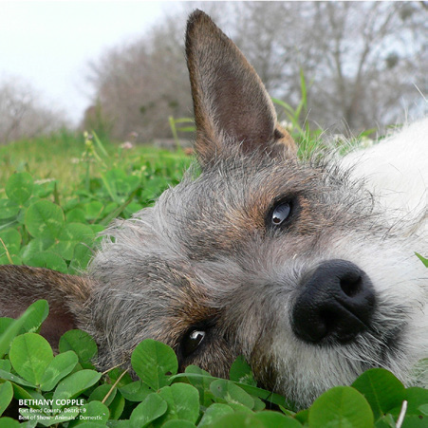
ANIMALS - WILDLIFE  Category focuses on animals not tamed or domesticated and commonly found in the wild throughout the country and world. Photos can be of wildlife in nature, zoos, and/ or petting zoos. |  | Deer, snakes, insects, rodents, elephants, etc. | 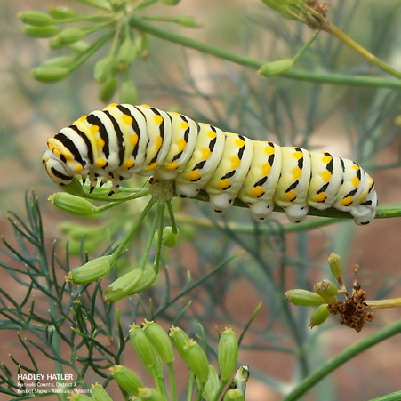
CATCH-ALL  Category for photos that do not fit into one of the other categories. This includes such photos as still-life, motion-blur, Polaroid transfers, SX-70 images, hand colored photos. | Do not submit a photo in this category which can clearly be submitted in another photography category. Catch-all is not intended for counties to use to eliminate duplicate photos from multiple 4-H members. | Polaroid image & emulsion transfers, still-life, long exposure zoomed images, and painting with light. | 
DETAILS & MACRO  Getting in close is the name of the game for this category. We welcome pictures of small details that suggest a larger story. This is also the place for macro photographs (although a macro image of a flower might equally go into the Flowers category). |  | Detail of a knot, a lock, or an abstract close-up - anything as long as it is a tight composition of a detail. Macro examples include parts of a flower bloom, insects, stamps, ice crystals, etc. | 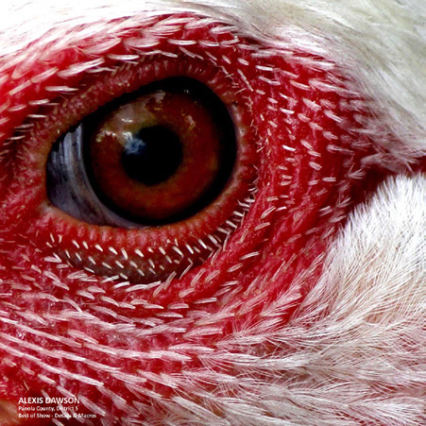
DIGITAL DARKROOM  Photos are for digital art - images created or drastically altered in software like Adobe Photoshop®. For this category, a 4-H member will submit a minimum of at least two photos that demonstrate the before photo(s) and the altered, or final, digital piece. The multiple photos will illustrate the alterations made to the original photos. All photos should be incorporated into one file for submission. |  | Photoshop® composites and creations, images greatly manipulated with a variety of filters, photos with artistic borders, photos stitched into a panoramic. | 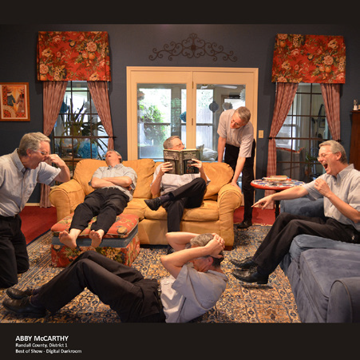
DOMINANT COLOR  Photos with a dominant color. The dominant element in the image must be a specific color, such as red, yellow, blue, white, black, white, green, etc. Black & White photos, duotones, are excluded from this category. |  | Bowl of lemons, in a yellow bowl, on top of a yellow table covering, with a bright yellow tone sun lighting on it. | 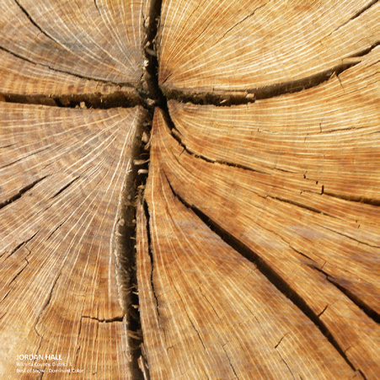
ELEMENTS OF DESIGN  Images use of graphic elements of design. Photos that showcase line, shape, pattern, form, texture, perspective, etc. Photo can consist of any subject matter. Category is not for graphic illustrations made in commercial programs (i.e. Adobe Illustrator®) nor for extreme digital creations. |  | Perspective, Line, Pattern. | 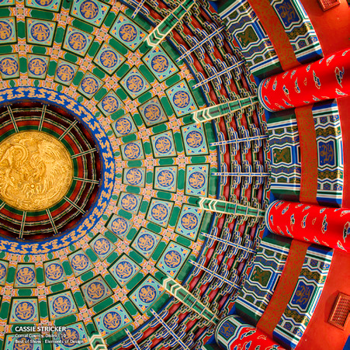
FOOD  Category is a still life specialization of photography, aimed at producing attractive photographs of food for use in such items of advertisements, packaging, menus and/or cookbooks. | NO PHOTOS OF ALCOHOL BEVERAGES ARE ALLOWED! | Thanksgiving dinner, cakes/pies, fruits and place settings, Easter eggs, sandwiches, ingredients, etc. | 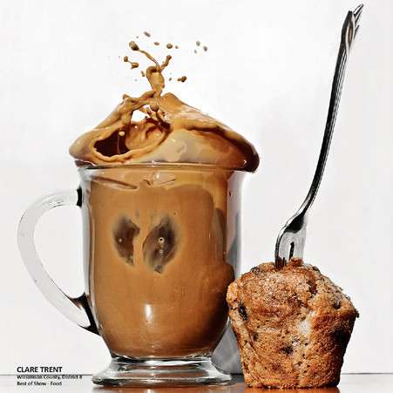
MARINE/AQUATIC  Photos of any LIVING ORGANISM in bodies of either fresh or ocean (salt) water. | NO PHOTOS OF BOATS, SHIPS, OR FISHING SUPPLIES | Fish, stingrays, whales, starfish, divers under water, etc. | 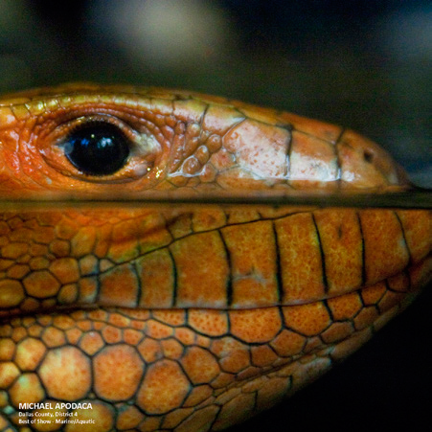
NATURE & LANDSCAPE  The focus of this category includes landscapes, outdoor scenics, nature images, sunsets, urban landscapes, seascapes, cityscapes, and farms. Images focus on the beauty of the outdoors. |  | Landscapes, Scenics, Outdoors. | 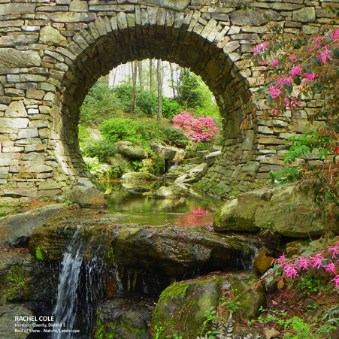
NIGHT PHOTOGRAPHY  Photos taken outdoors between after-dusk and before dawn. Generally these photos are achieved by using artificial light or using a long exposure. This category can include any subject as long as the focus is on the skill and technique used to acquire the photograph. | NO PHOTOS OF SUNSETS OR SUNRISES - NO SUNLIGHT AT ALL!!!!!! | Fireworks, lighting on buildings/structures, animals, plant/flora, people, etc. | 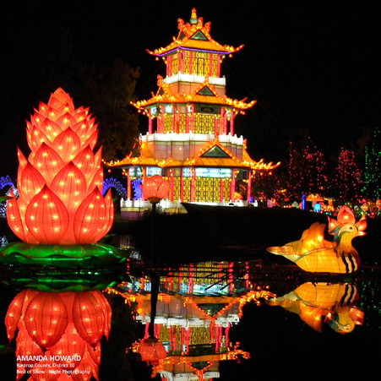
PEOPLE  Photos focus from all walks of life, parenting and family, children, babies, models/ fashion, sports, and couples. See Rule #8 above. |  | Kids & Family, Models/Fashion, Sports. | 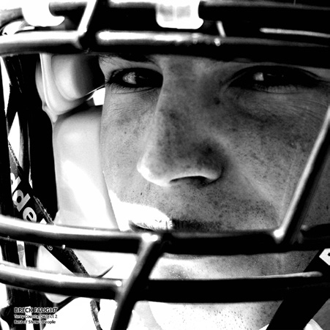
PLANT/FLORA  Photos of interesting, unique, and beautiful flowers and flora. Photography can occur outdoors or indoors. Photo subject should be that of a single flower, plant, bush, tree, etc. Large collections of plant/flora should be considered for entry into the Nature & Landscape category. |  | A rose, an upward shot of a tree, a flower bouquet, etc. | 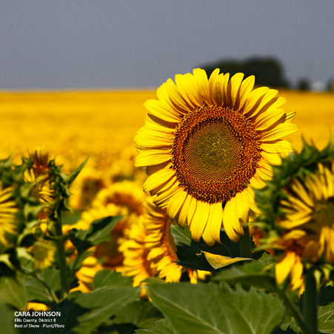
STORYBOARD  A storyboard is one digital entry (one photo) that contains three smaller images and minimal text that tells a story. The story should be easily understood by the viewer. This entry is one single file. |  | Three images depicting the blooming of a rose bud at different stages, with the title of “Beginning of Beauty”. | 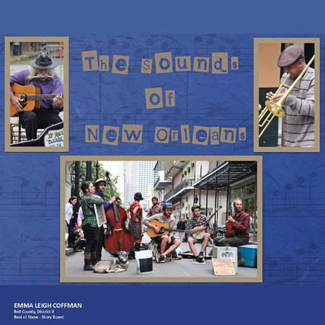
THEME  Theme photo focuses on a subject announced and outlined in the contest rules and guidelines. For 2013-14 the theme is “What is Your WHY?” This year theme will focus on WHY you are part of 4-H. Think about why you are a member of Texas 4-H and then take a photo. It could be focused on leadership, community service, a particular project, a 4-H meeting, or your 4-H friends. | Photos which have been entered into other categories. | Images of 4-H members in action at a meeting, a community service project, or working at a county fair. Project photos which depict both the project and a 4-H member are also allowed. | 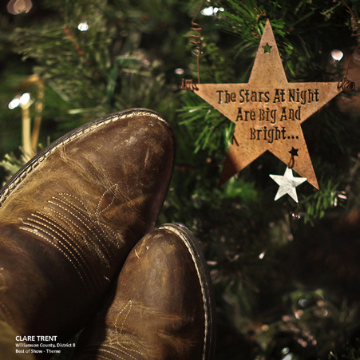

DISTRICT 8 4-H PHOTOGRAPHY CONTEST
Judging Criteria

Each photograph will be judged against the following set of judging criteria, and not against photographs of your peers. Based on total points awarded for each photograph, the participant will be awarded a blue, red, white, or a participation ribbon. The elements for judging the photographs will be:

IMPACT  (Max Points: 15 ) | Impact is the sense one gets upon viewing an image for the first time. Compelling images evoke laughter, sadness, anger, pride, wonder or another intense emotion. There can be impact in any of these twelve elements.
CREATIVITY  (Max Points: 15) | Creativity is the original, fresh, and external expression of the imagination of the maker by using the medium to convey an idea, message or thought.
TECHNICAL  (Max Points: 25) | Technical is the quality of the image itself as it is presented for viewing, which includes the following aspects:  - Allowable amounts of retouching and adjustments (removal of red eye, cropping, minor straightening)  - Sharpness and correct color balance.  - Lighting, which includes the use and control of light. The use of lighting whether natural or man-made and its proper use to enhance the image.  - Posing and capturing of the image
COMPOSITION  (Max Points: 20) | Composition is important to the design of an image, bringing all of the visual elements together in concert to express the purpose of the image. Proper composition holds the viewer in the image and prompts the viewer to look where the creator intends. Effective composition can be pleasing or disturbing, depending on the intent of the image maker.
SUBJECT MATTER  (Max Points: 15) | Subject Matter should always be appropriate to the story being told (i.e. category the photo is entered into) in an image. Subject matter also includes the center of interest for the photograph or where the maker wants the viewer to stop and they view the image.
STORYTELLING  (Max Points: 10) | Story Telling refers to the image’s ability to evoke imagination. One beautiful thing about art is that each viewer might collect his own message or read her own story in an image.

DISTRICT 8 4-H PHOTOGRAPHY CONTEST
Score Sheet

You are competing against previously determined standards of excellence, not against your peers. Before preparing your entry for submission please carefully review the judging criteria.

Name: |  |  |  |  |  | County:
Check one in each of the following:
Age Division: |  | Junior |  | Intermediate |  | Senior
Category: |  | Animals- Domestic |  | Details & Macros |  | Elements of Design |  | Nature & Landscape |  | Plant/Flora
 |  | Animals-Wildlife |  | Digital Darkroom |  | Food |  | Night Photography |  | Storyboard
 |  | Catch-All |  | Dominant Color |  | Marine/Aquatic |  | People |  | Theme

CRITERIA | POINTS AWARDED (circle one number on each row)
Impact | 1 | 2 | 3 | 4 | 5 | 6 | 7 | 8 | 9 |  | 10 | 11 | 12 | 13 | 14 | 15
Creativity | 1 | 2 | 3 | 4 | 5 | 6 | 7 | 8 | 9 |  | 10 | 11 | 12 | 13 | 14 | 15
Technical | 1 | 2 | 3 | 4 | 5 | 6 | 7 | 8 | 9 |  | 10 | 11 | 12 | 13 | 14 | 15 | 16 | 17 |  | 18 | 19 | 20 | 21 | 22 | 23 | 24 | 25
Composition | 1 | 2 | 3 | 4 | 5 | 6 | 7 | 8 | 9 |  | 10 | 11 | 12 | 13 | 14 | 15 | 16 | 17 |  | 18 | 19 | 20
Subject Matter | 1 | 2 | 3 | 4 | 5 | 6 | 7 | 8 | 9 |  | 10 | 11 | 12 | 13 | 14 | 15
Storytelling | 1 | 2 | 3 | 4 | 5 | 6 | 7 | 8 | 9 |  | 10
TOTAL POINTS
AWARD (circle one) | Blue Award  (71-100 points) |  |  |  |  |  |  |  |  | Red Award  (31-70 points) |  |  |  |  |  |  |  |  | White Award  (0-30 points)
JUDGES COMMENTS

